**1. Business Functions:**

**Objective of the Company:** Canada Flowers is an online flower delivery service that has been providing local, national, and international flower delivery services. They offer a wide range of floral and gift items suitable for various occasions and sentiments. Their catalog includes fresh flowers, plants, balloons, chocolates, and gift baskets. They also ensure timely delivery to recipients across Canada.

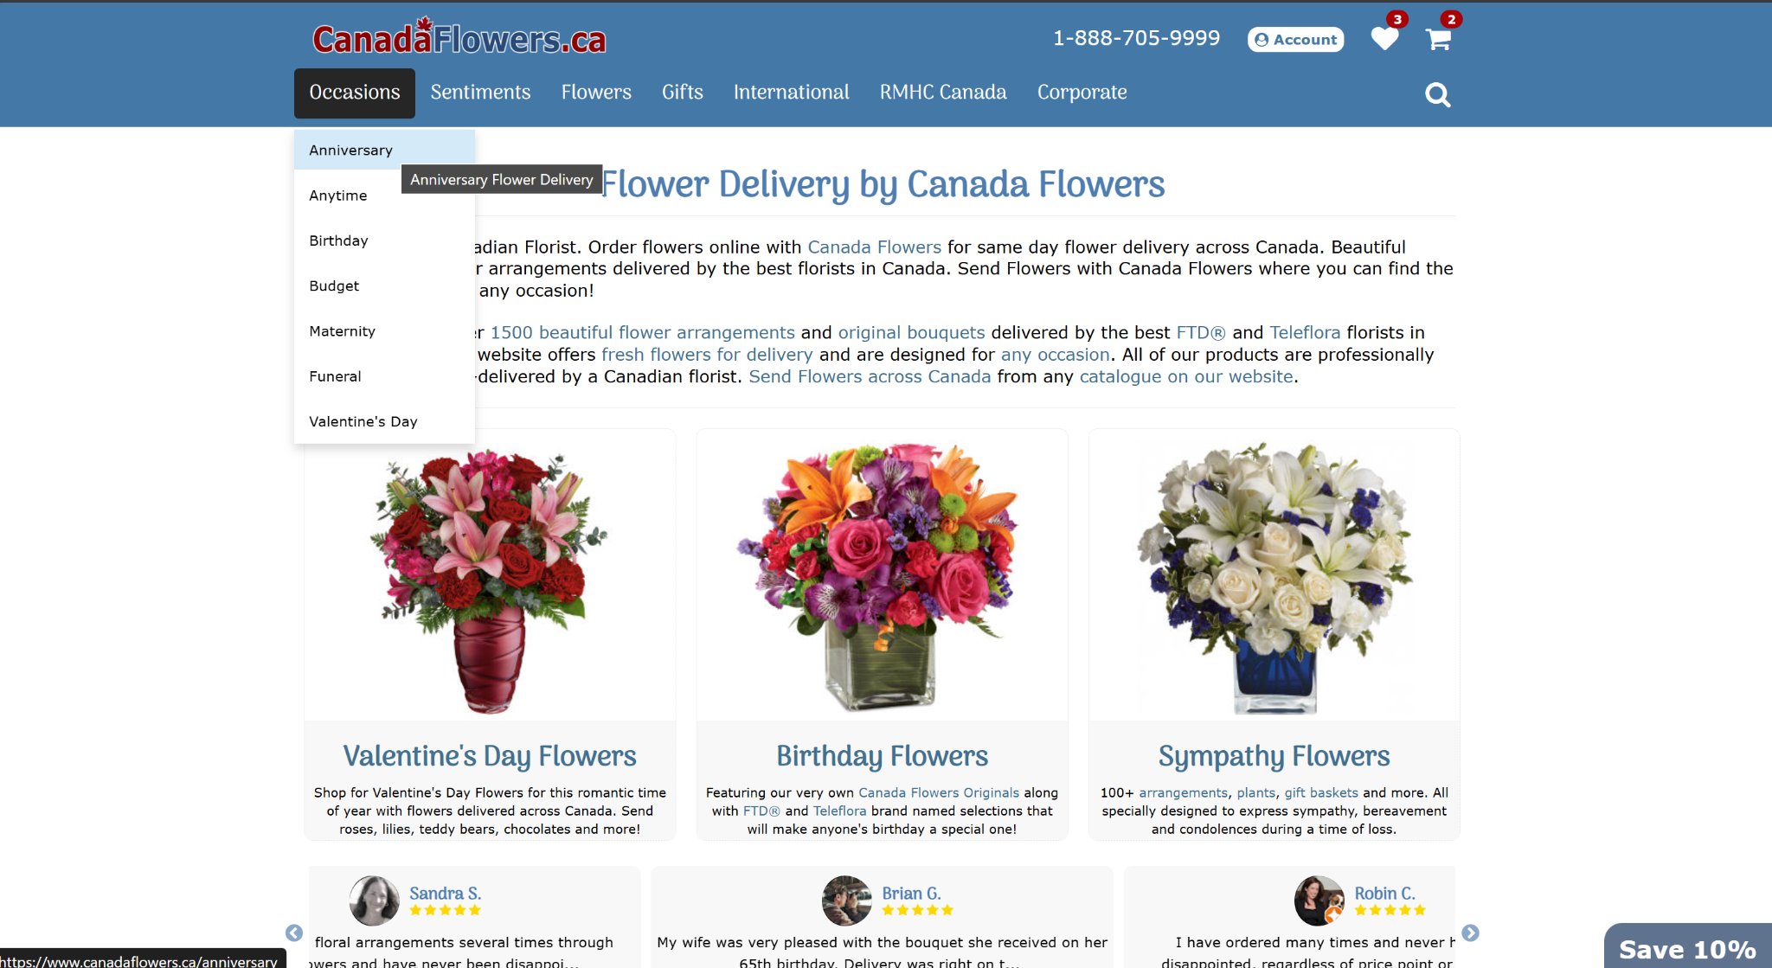

As a customer, you can browse products by categories such as occasions, sentiments, flowers, gifts, corporate, etc. Selecting a category displays a list of products with their image, name, description or item number, and price. Selecting a product provides a detailed description, included flowers, pricing options, and similar products.

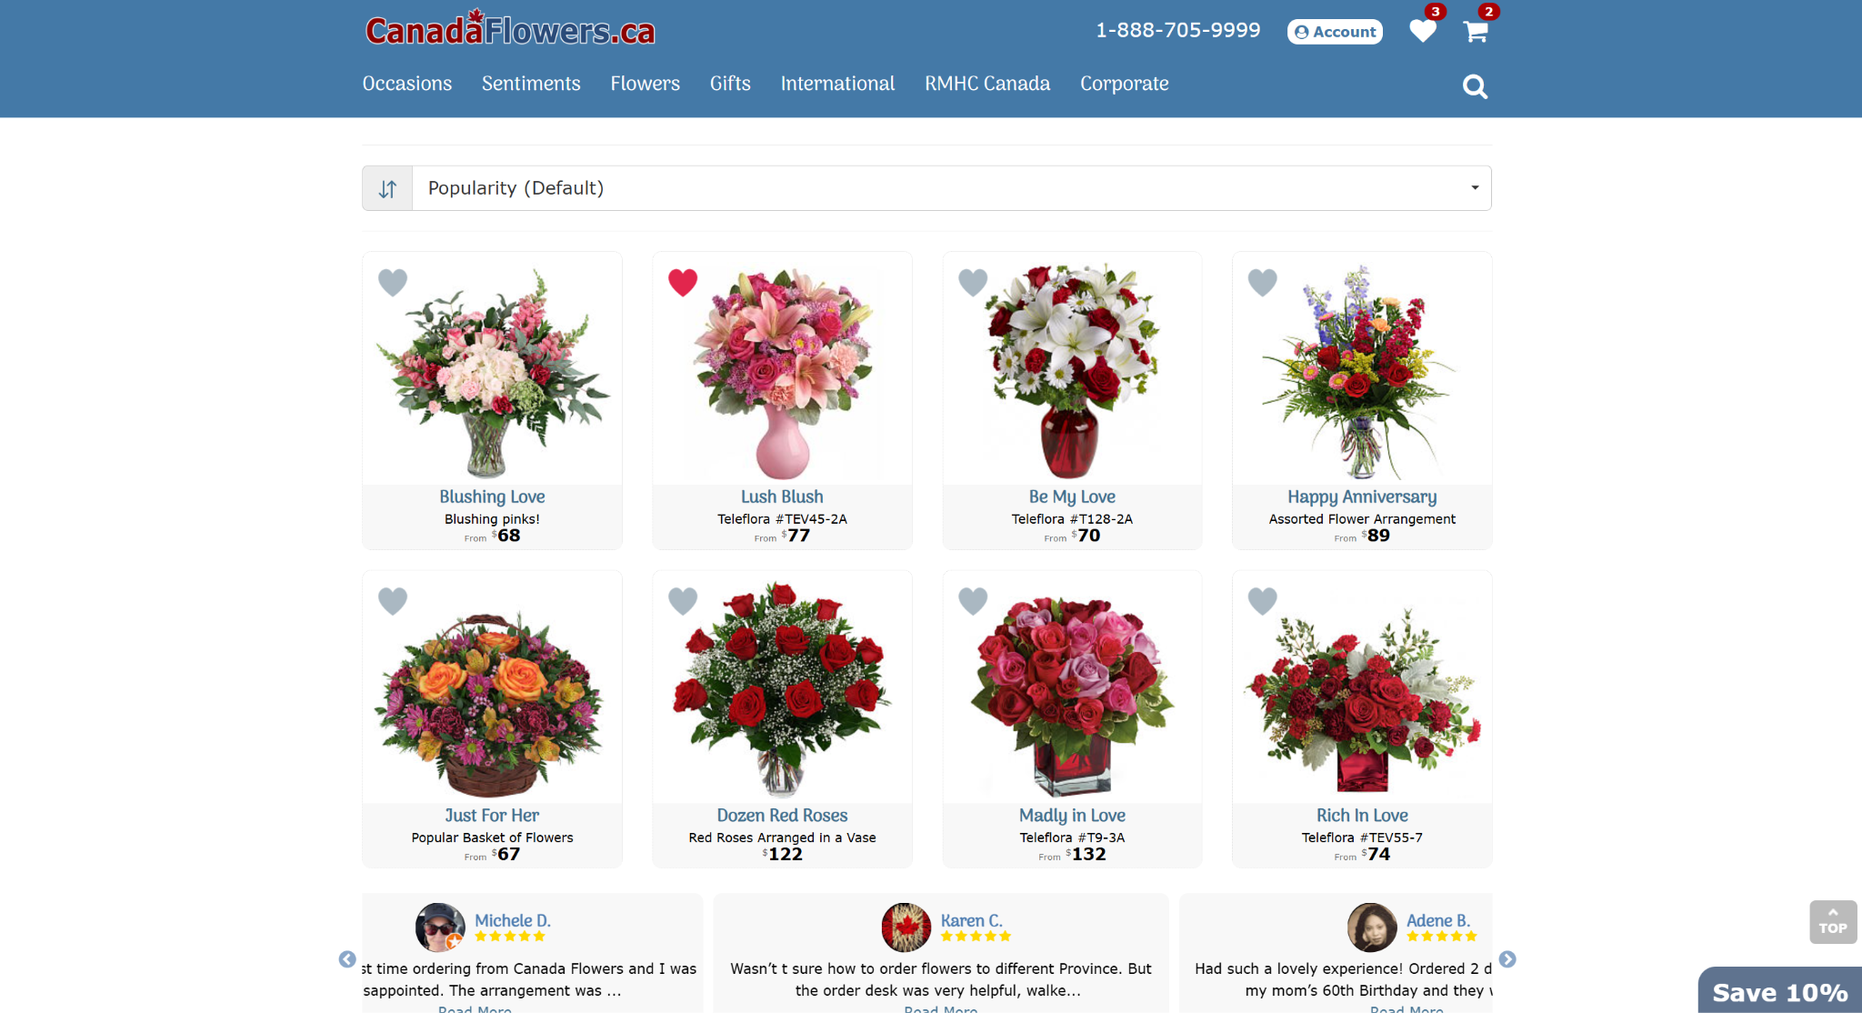

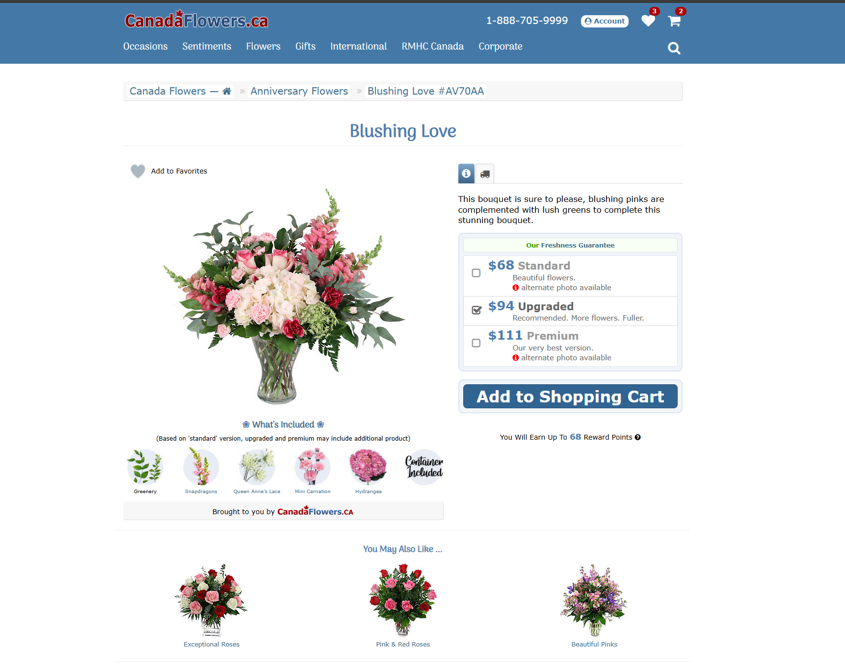  
From there, you can add the product to your shopping cart or favourites. The cart displays all selected products with their details and offers the option to include add-ons such as balloons, teddy, or chocolates at unit pricing.

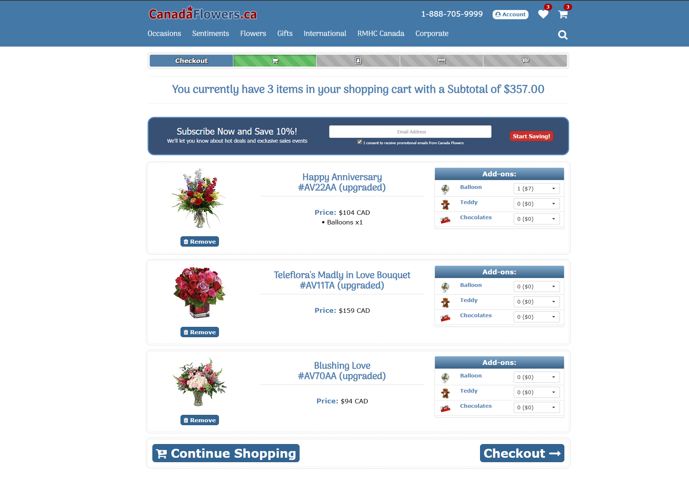

From the cart, you can either continue shopping or proceed to checkout. The checkout page displays product details and requires you to fill in delivery information, choose a delivery date, set a reminder before delivery if required, add delivery instructions and include a message on a card. You can also select the occasion for the purchase and apply a 10% promotion code by signing up with your email.

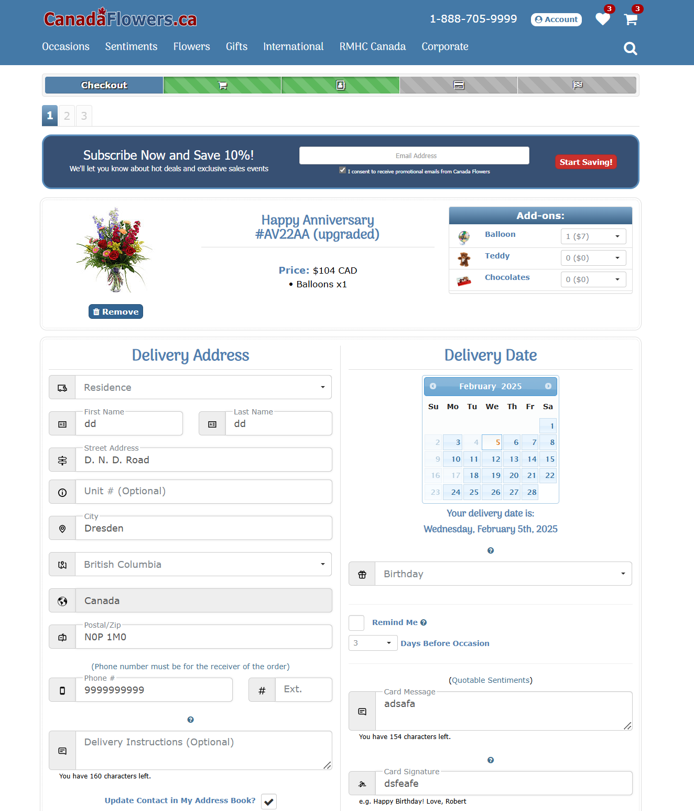

After entering billing and payment details, you can optionally donate to "Ronald McDonald House Charities." Finally, you can review your order summary, apply a promo code, redeem points, or use a gift card if applicable before submitting your order.

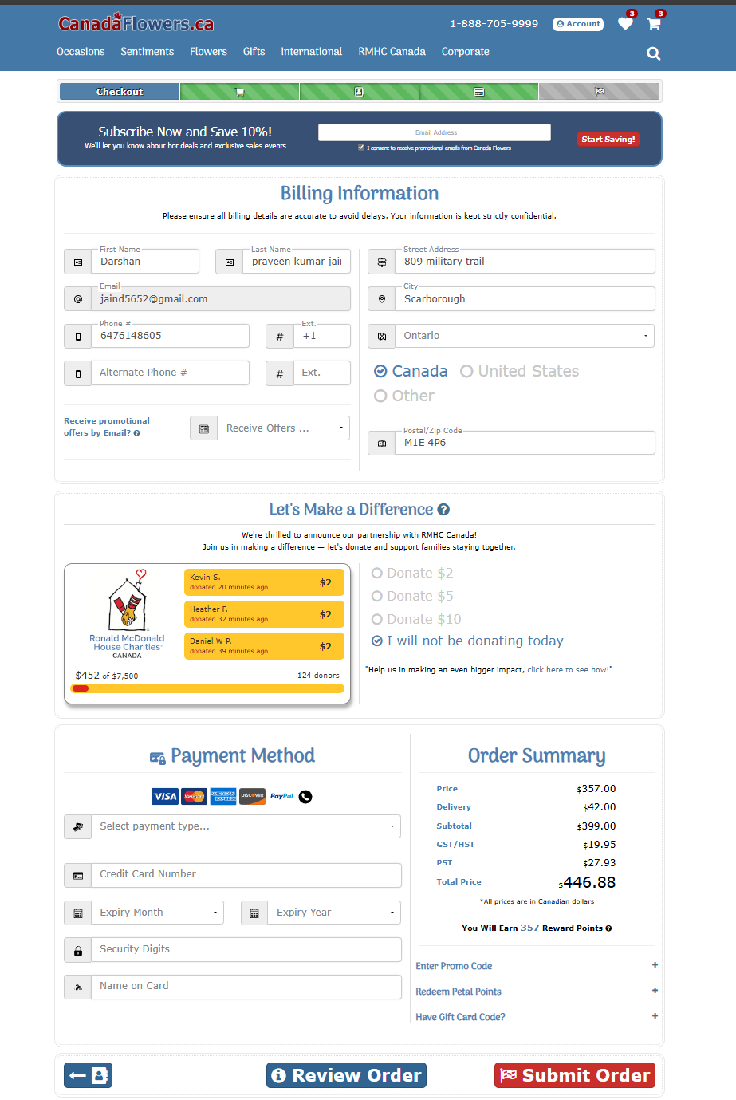

**2. Business Rules And Assumptions:**

1. **Entities and Attributes Required For Database:**

* For each PRODUCT CATEGORY: a unique CategoryID and the Category Name is required.
* For each PRODUCT being sold: a unique Product ID, Product Name, Product Description, Product Price and Category ID as foreign key is required.
* For each CUSTOMER: a unique Customer ID, Customer Name (First name, Last name), Email Address, Password, Contact Number(multivalued) and Customer Address containing Street Address, City, Province, Country and Postal Code is required.
* For each CART: a unique Cart ID and the Customer ID is required as foreign key.
* For each CART LINE: Product ID and Cart ID are required as foreign keys and it also requires a Quantity attribute.
* For each FAVOURITES: CustomerID and ProductID are required as foreign keys.
* For each ORDER: a unique OrderID, CustomerID as foreign key, Order date, Order status and Order total is required.
* For each ORDERLINE: OrderID and ProductID are required as foreign keys and also a Quantity attribute.
* For each PAYMENT: a unique PaymentID, OrderID as foreign key, Payment date, Payment amount and Card details containing Card number, Card expiry month, Card expiry year, CVC and Card holder name.
* For each RECIPIENT: a unique RecipientID, OrderID as foreign key, Recipient name, Address and phone number(multivalued) is required.

1. **Relationship Between Attributes:**

* Each Product category has one or more products. Each product belongs to exactly one category.
* A Product can be added to multiple favourites or no favourites. Each favourites may have no products or exactly one product.
* A customer can add to one favourites optionally. Only one customer can add it at a time optionally.
* A customer can add to one cart optionally. A product can be added to cart only by one customer optionally.
* A cart has one or many cart lines. Each cart line belongs to exactly one cart only.
* Each cart line includes one product or no product. A product can be a part of many cart lines or no cart line. The purpose of cart line is to hold a product temporarily a user considers purchasing which can later be removed or added easily before finalizing the order.
* A customer can place many orders or no orders. Each order can only be placed by exactly one customer.
* An order has one or many order lines. Each order line belongs to exactly one order.
* An order line includes one product or no product. A product can belong to multiple order lines or no order line.
* Each order includes exactly one payment and each payment belongs to exactly one order.
* An order has exactly one recipient and a recipient has exactly one order.

1. **ER MODEL:**

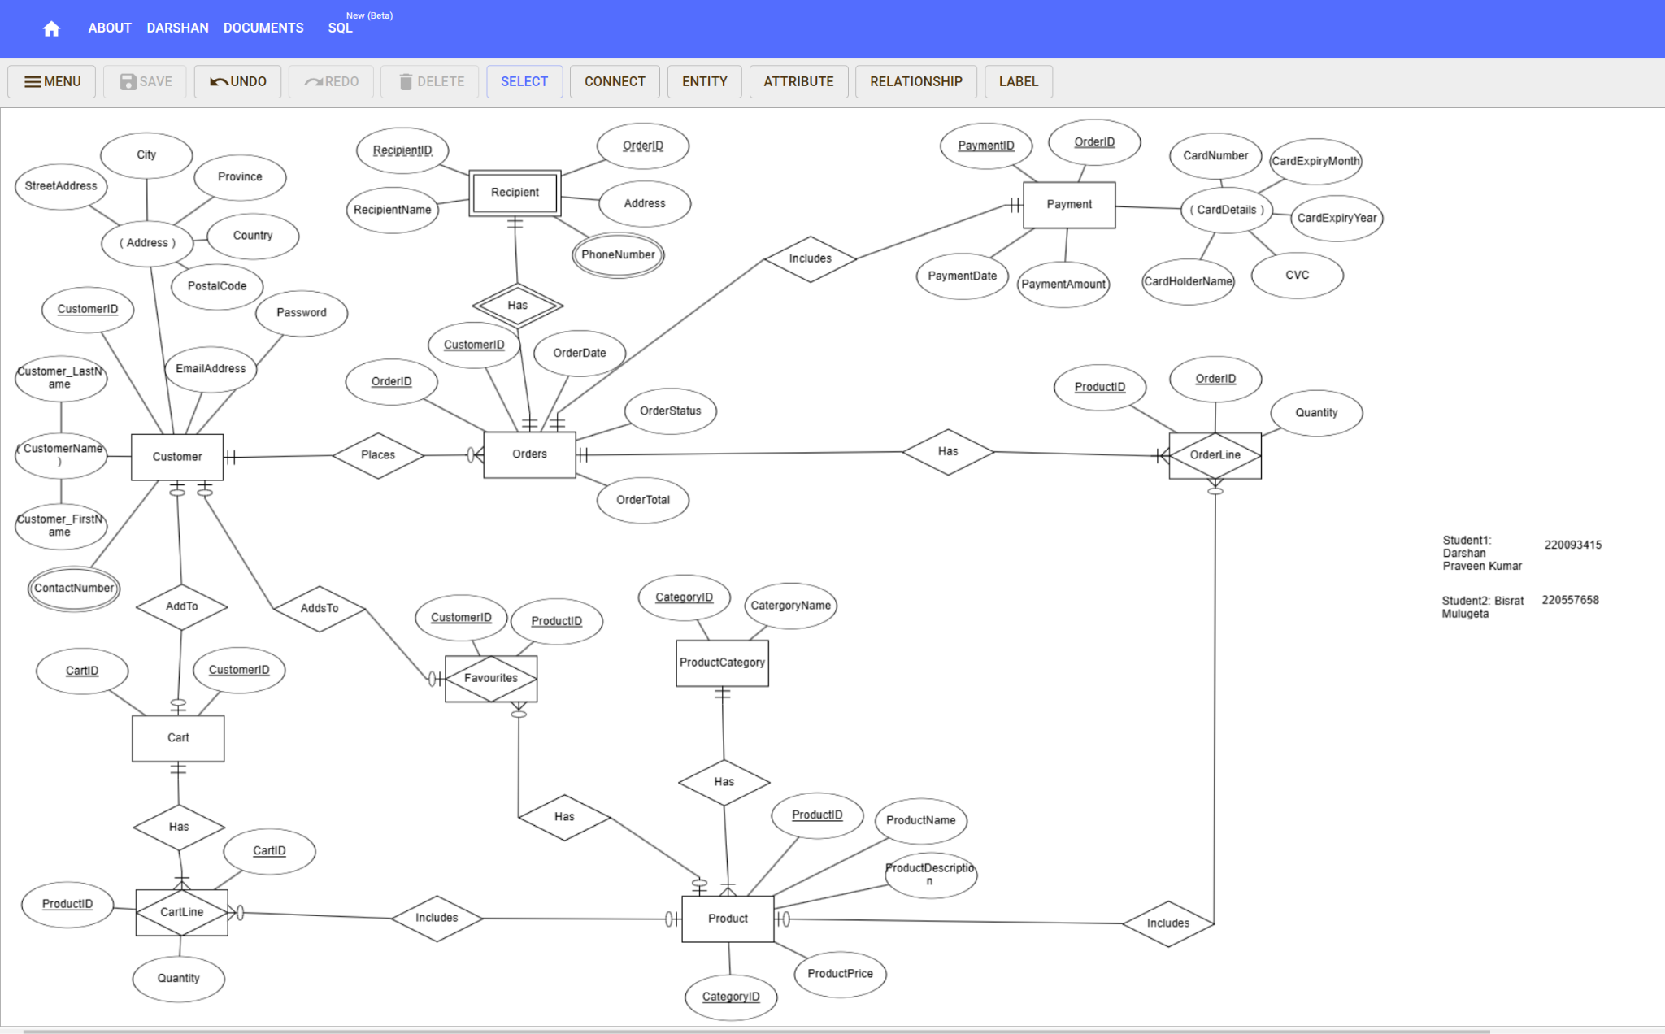

The ER diagram is also attached as an image file.

1. **E-R model to relational tables:**

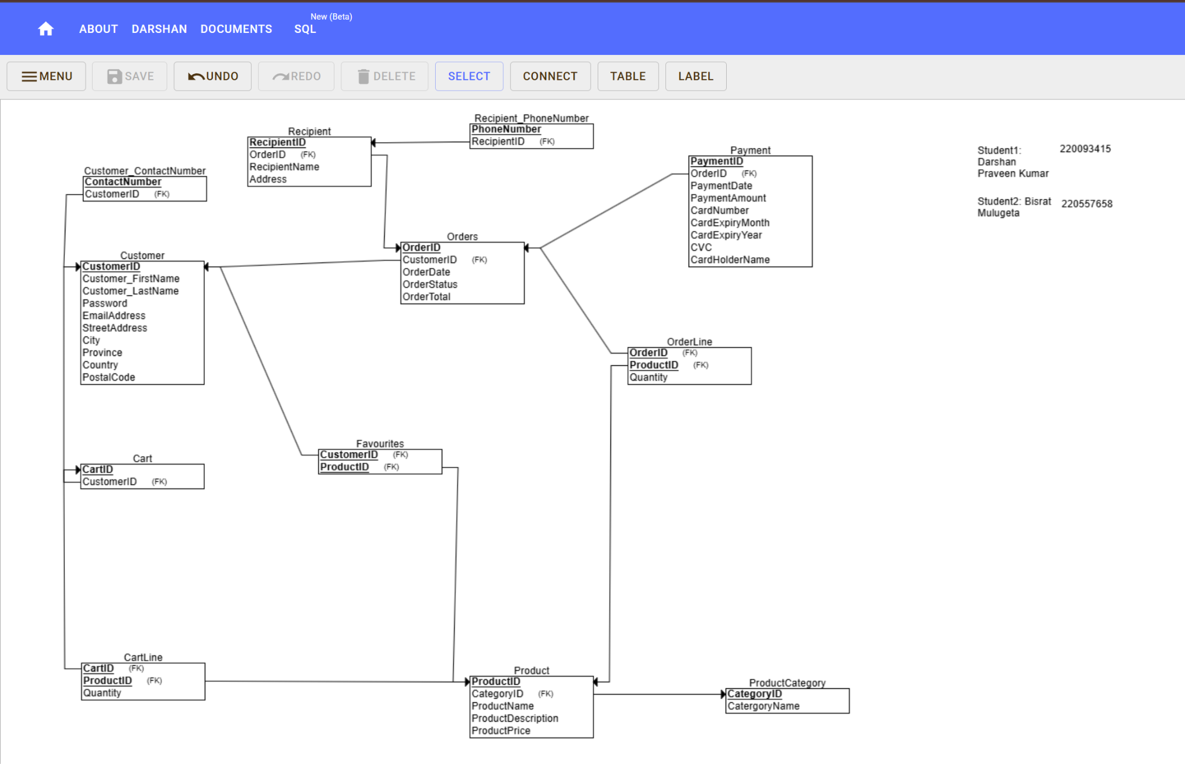

The Relational Schema is also attached as an image file.

**Tables With Sample Data:**

**ProductCategory:**

| Category_ID(PK) | CategoryName | |
| --- | --- | --- |
| 401 | Valentine's Day |  |
| 402 | Maternity |  |
| 403 | Funeral |  |
| 404 | Birthday | |
| 405 | Anniversary |  |

**Product:**

| ProductID(PK) | ProductName | ProductPrice | ProductDescription | CategoryID(FK) |
| --- | --- | --- | --- | --- |
| 301 | Orchids | 34 | Fresh and new | 401 |
| 302 | Rose | 87 | Unique | 402 |
| 303 | Sunflower | 78 | red as wine | 403 |
| 304 | Orchids | 76 | Natural from Farm | 404 |
| 305 | Carnations | 87 | Perfect color | 405 |

**Customer:**

| CustomerID(PK) | FirstName | LastName | EmailAddress | Password | StreetAddress | City | Province | Country | PostalCode |
| --- | --- | --- | --- | --- | --- | --- | --- | --- | --- |
| 111 | LeBron | James | lebron.james@gmail.com | pass123 | 2 Justice Way | Calgary | AB | Canada | M4W 1A1 |
| 112 | Serena | Williams | serena.w@gmail.com | secretd45 | 3 Wisdom St | New York | NY | USA | V6Z 2Y7 |
| 113 | Lionel | Messi | messi.l@gmail.com | pass789df | 44 Reflection Ave | Calgary | AB | Canada | T2P 1S4 |
| 114 | Roger | Federer | roger.f@gmail.com | pass456 | 1 Ethics St | Vancouver | BC | Canada | K1N 8Y7 |
| 115 | Megan | Rapinoe | megan.r@gmail.com | pass321 | 4 Knowledge Dr | London | ON | Canada | H3G 2N1 |

**Customer Contact Number:**

* The below table shows that each recipient may have multiple phone numbers.

| CustomerID(FK) | ContactNumber |
| --- | --- |
| 111 | 1234567890 |
| 111 | 987654321 |
| 113 | 1122334455 |
| 114 | 2233445566 |
| 115 | 3344556677 |

**Cart:**

| CartID(PK) | CustomerID |
| --- | --- |
| 201 | 111 |
| 202 | 112 |
| 203 | 113 |
| 204 | 114 |
| 205 | 115 |

**Cart Line:**

| CartID(FK) | ProductID(FK) | Quantity |
| --- | --- | --- |
| 201 | 301 | 1 |
| 202 | 302 | 2 |
| 203 | 303 | 3 |
| 204 | 304 | 4 |
| 205 | 305 | 5 |

**Favourites:**

| CustomerID(FK) | OrderID(FK) |
| --- | --- |
| 111 | 1011 |
| 112 | 1022 |
| 113 | 1033 |
| 114 | 1044 |
| 115 | 1055 |

**Order:**

| OrderID(PK) | OrderDate | OrderTotal | OrderStatus | CustomerID(FK) |
| --- | --- | --- | --- | --- |
| 1011 | 2025-01-01 | 99 | Delivered | 111 |
| 1022 | 2025-01-02 | 999 | Delivered | 112 |
| 1033 | 2025-01-03 | 231 | Delivered | 113 |
| 1044 | 2025-01-04 | 123 | Shipped | 114 |
| 1055 | 2025-01-06 | 9999 | Pending | 115 |

**Order Line:**

| Order_ID(FK) | ProductID(FK) | Quantity |
| --- | --- | --- |
| 1011 | 301 | 1 |
| 1022 | 302 | 2 |
| 1033 | 303 | 3 |
| 1044 | 304 | 4 |
| 1055 | 305 | 5 |

**Payment:**

| PaymentID(PK) | PaymentDate | PaymentAmount | CardNumber | CardExpiryMonth | CardExpiryYear | CVC | CardHolderName | OrderID(FK) |
| --- | --- | --- | --- | --- | --- | --- | --- | --- |
| 1 | 2024-01-10 | 81 | 4228164769594755 | 9 | 2026 | 373 | LeBron James | 1011 |
| 2 | 2024-01-11 | 102.97 | 4308086650476922 | 3 | 2030 | 996 | Serena Gomez | 1022 |
| 3 | 2024-01-12 | 193.37 | 4468838022009719 | 12 | 2029 | 207 | Lionel Messie | 1033 |
| 4 | 2024-01-13 | 235.81 | 4170849707793064 | 4 | 2030 | 530 | Roger Federer | 1044 |
| 5 | 2024-01-14 | 98.82 | 4940274178083025 | 2 | 2025 | 168 | Megan Rapinoe | 1055 |

**Recipient:**

| RecipientID(PK) | OrderID(FK) | ReceiverName | Recipient_Address |  |  |
| --- | --- | --- | --- | --- | --- |
| 11 | 1011 | Hannah Arendt | 222 Justice Way, AB | |  |
| 12 | 1022 | Martha Nussbaum | 123 Wisdom St, NY | |  |
| 13 | 1033 | Mary Wollstonecraft | 444 Reflection Ave, WA | | |
| 14 | 1044 | Elizabeth Anscombe | 111 Ethics St, BC | |  |
| 15 | 1055 | Iris Murdoch | 654 Knowledge Dr, ON | | |

**Recipient PhoneNumber:**

* The below table shows each recipient may have multiple phone number

| RecipientID(FK) | RecipientNumber |
| --- | --- |
| 11 | 1234567890 |
| 11 | 987654321 |
| 13 | 1122334455 |
| 14 | 2233445566 |
| 15 | 3344556677 |

**5.Normalization Check:**

Most of the entities are either already in 3NF or have been converted into 3NF during relational table conversion like customer number and recipient number which were moved to a new table. The remaining entities that need to be normalised are as below:

**Customer**

| CustomerID | FirstName | LastName | EmailAddress | Password | StreetAddress | City | Province | Country | PostalCode |
| --- | --- | --- | --- | --- | --- | --- | --- | --- | --- |
| 111 | LeBron | James | lebron.james@gmail.com | pass123 | 2 Justice Way | Calgary | AB | Canada | M4W 1A1 |
| 112 | Serena | Williams | serena.w@gmail.com | secretd45 | 3 Wisdom St | New York | NY | USA | V6Z 2Y7 |
| 113 | Lionel | Messi | messi.l@gmail.com | pass789df | 44 Reflection Ave | Calgary | AB | Canada | T2P 1S4 |
| 114 | Roger | Federer | roger.f@gmail.com | pass456 | 1 Ethics St | Vancouver | BC | Canada | K1N 8Y7 |
| 115 | Megan | Rapinoe | megan.r@gmail.com | pass321 | 4 Knowledge Dr | London | ON | Canada | H3G 2N1 |

The customer table is in First Normal Form (1NF) because:

1. Atomic Values: Each column contains atomic (indivisible) values. For example, columns like FirstName, LastName, EmailAddress, Password, etc., contain single values per cell.
2. Unique Rows: Each row is uniquely identified by the CustomerID column, which acts as the primary key.
3. No Repeating Groups: There are no multiple values in a single column or nested tables within the table.

Since the first table satisfies the above criteria, it is in 1NF.

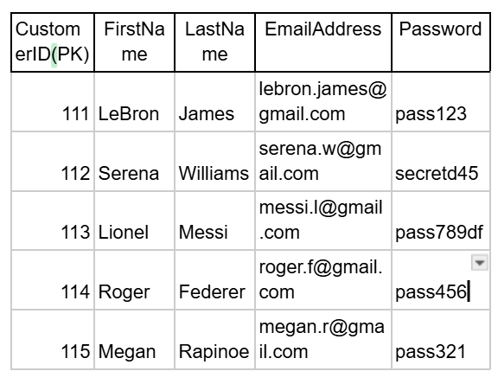

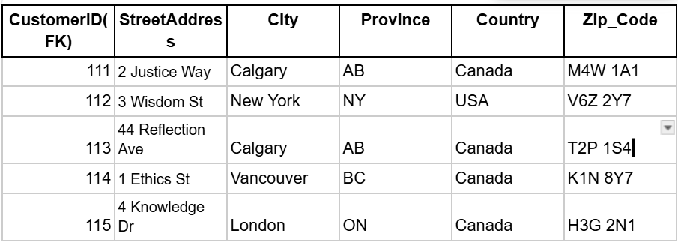

The above two tables:

1. Customer Table:

* Contains CustomerID, FirstName, LastName, EmailAddress, and Password.

1. Address Table:

* Contains CustomerID as foreign key, StreetAddress, City, Province, Country, and PostalCode.

These two tables are in Second Normal Form (2NF) because:

1. No Partial Dependencies:

* In the original table, StreetAddress, City, Province, Country, and PostalCode depend on CustomerID but not on other attributes like FirstName or Password.
* By moving address-related attributes to a separate table (Address Table), each non-key attribute now depends entirely on the primary key (CustomerID) of its respective table.

1. Elimination of Redundancy:

* Separating the data into two tables reduces redundancy and avoids duplication of address data when customers might have multiple addresses.

1. Maintained Relationships:

* The two tables are linked through CustomerID, ensuring data integrity and allowing retrieval of full customer information through joins.

Thus, it is in 2NF.

* There is no transitive dependency because none of the non-key attributes depend on other non-key attributes. For example, FirstName, LastName, EmailAddress, and Password all depend directly on CustomerID.
* 3NF satisfied.

The Customer Table is in 3NF.

* Attributes like StreetAddress, City, Province, Country, and PostalCode describe the address and are directly dependent on CustomerID.
* While StreetAddress → City, Province, Country, PostalCode might seem like a transitive dependency, it is not in this case because:
* These attributes are inherently part of the address data and are dependent on the key (CustomerID).
* StreetAddress is not acting as a determinant within the table (it's not the primary key).

There are no transitive dependencies, so the address table is in 3NF.

**PAYMENT:**

| PaymentID(PK) | PaymentDate | PaymentAmount | CardNumber | CardExpiryMonth | CardExpiryYear | CVC | CardHolderName | OrderID(FK) |
| --- | --- | --- | --- | --- | --- | --- | --- | --- |
| 1 | 2024-01-10 | 81 | 4755 | 9 | 2026 | 373 | LeBron James | 1011 |
| 2 | 2024-01-11 | 102.97 | 6922 | 3 | 2030 | 996 | Serena Gomez | 1022 |
| 3 | 2024-01-12 | 193.37 | 9719 | 12 | 2029 | 207 | Lionel Messie | 1033 |
| 4 | 2024-01-13 | 235.81 | 3064 | 4 | 2030 | 530 | Roger Federer | 1044 |

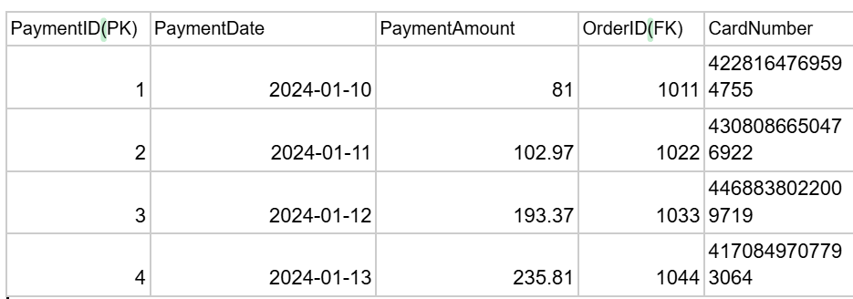

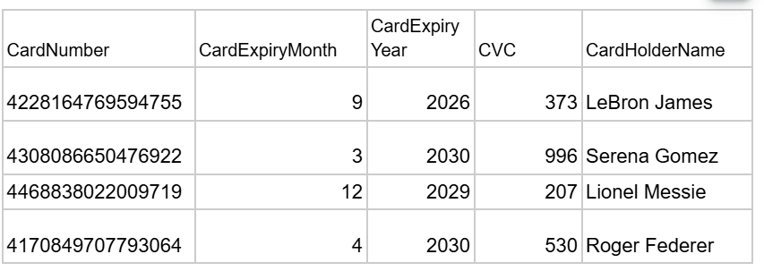

The payment table has also been normalised.